Shabbos Stories for
Parshas bereishis 5779
Volume 10, Issue 7 27 Tishrei 5778/ October 6, 2018
Printed L’illuy nishmas Nechama bas R’ Noach, a”h

For a free subscription, please forward your request to keren18@juno.com

L’Maaseh… A Tale to Remember
The King’s Gift

Rav Yisroel Reisman, Shlit”a, once related the following story, which happened to someone on the west side of Manhattan, and it gives an incredible insight into the requests we ask of Hashem.

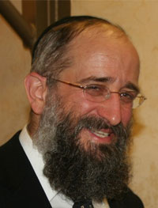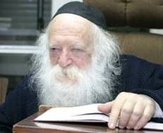
Rabbi Yisroel Reisman Rabbi Chaim Kanievski

A wealthy, Jewish individual who lives in one of the tall, prestigious buildings on the west side, was one day going down the elevator of his building. There was someone else in the elevator with him, and he asked the other fellow why there were so many police cars in front of the building that day.
The fellow answered him that he lives in the penthouse of the building, and he is the son of the king of Morocco, and he is a prince. He explained that his father, the king of Morocco was visiting America, and he also came to visit his son that day, and that was why there was a police presence outside the building.
The man couldn’t believe what he heard, and the prince asked him if he would like to meet his father, the king, and the man said that of course he would. It is no small thing to meet a king, as there is a Brachah to recite over it.
The prince told this man to come over that night at eight o’clock to meet him. This man happened to have had a son who had just become Bar Mitzvah, and he took his son along with him to meet the king. They went up to the penthouse, were escorted inside, and they met the king of Morocco and spoke with him for a few minutes.
The king was very moved by the Bar Mitzvah Bochur, and he asked him a few questions. He asked him how old he was, and the boy answered that he was 13. The king said that he knew that 13 is a special age for a Jewish boy, and the boy said, “Yes, I was just Bar Mitzvah. I am going to Eretz Yisroel to see the Gedolim there and Daven there. It is a week after my Bar Mitzvah.”
The visit ended shortly after that, and it was very pleasant. The next day, this man went to his mailbox to get the mail, and he found that the king had left a check for the Bar Mitzvah boy as a gift. He was completely stunned when he saw that it was written out for $50,000!
The father was very embarrassed and he went straight back up to see the prince. He thanked him for the gift, and he said, “I don’t know what you think the Jews do for Bar Mitzvah presents. Some people give $180, some will give $360, but we don’t give $50,000 gifts to Bar Mitzvah Bochurim.”
The prince smiled and said to him, “You don't understand. Bar Mitzvah boys may get $180 gifts, but for the king of Morocco, it is inappropriate to give a gift of anything less than $50,000.”
This father then went with his son on their trip to Eretz Yisroel, and when he was by Rav Chaim Kanievsky, Shlit”a, he told him what happened with the king of Morocco.
Rav Chaim said to him, “Now I understand.”
The father was confused and asked what the Rav had understood.
Rav Chaim explained, “We say during the Yomim Nora’im, Avinu Malkeinu Asei Lemancha V’lo Lema’aneinu, ‘Our Father, our King, act for Your sake and not for ours!’ Why do we say this? Do we really care if Hashem acts for His Own sake or for ours? What do we mean when we say this?”
Rav Chaim said, “We only deserve $180 gifts, but for the Ribono Shel Olam, the King of the world, it is not appropriate to give a less fitting gift. Hashem gives Royal Gifts! That’s what we mean when we ask Hashem to give for His sake, that Hashem should give us as is fitting for the King to give a gift, not merely for our sake, or on our level!”
Rabbi Reisman concluded, “Let’s take these words and not limit what we ask for, because Hashem is listening in these days of mercy, where our Tefilos and requests are answered, and we can ask Hashem for everything because Hashem does everything for us!”

Reprinted from the Yom Kippur 5779 email of Torah U’Tefilah: A Collection of Inspiring Insights compiled by Rabbi Yehuda Winzelberg.

The Strange Advice of
The Chofetz Chaim

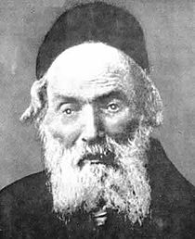

A lumber merchant would travel to Radin every year for Rosh Hashanah and Yom Kippur, in order to Daven with the Chofetz Chaim. One year, after Rosh Hashanah, the merchant went to discuss with the Chofetz Chaim a serious legal dispute in which he was involved with several non-Jewish people. The court case was scheduled for after Yom Kippur.
When the Chofetz Chaim heard the merchant’s dilemma, he ordered him to return home immediately so that he should be around in case legal issues came up that he needed to be around for.
The merchant was shocked. How could he leave his Rebbi, the Chofetz Chaim, just before Yom Kippur? But the Chofetz Chaim’s instructions were clear, and the merchant knew to follow his Rebbi’s words to the letter.
The merchant returned home immediately. The very night that he got home, a severe storm swept through the towns and villages. Strong winds, rain, thunder, and lightning pounded on the villager’s homes. In the middle of the storm, a group of Polish men who were on their way to the nearby forest, frantically pounded on the lumber merchant’s door.
The storm caught them by surprise and they were looking for shelter at the nearest house they could find. The lumber merchant welcomed them warmly into his home and supplied them with everything they needed.
As it turned out, one of his guests was none other than the judge who would be ruling in the merchant’s legal dispute! The judge was very grateful to the Jew who had helped him when he really needed it. On the day of his trial, the judge ruled in favor of the lumber merchant!

Reprinted from the Yom Kippur 5779 email of Torah U’Tefilah: A Collection of Inspiring Insights compiled by Rabbi Yehuda Winzelberg.

‘With Understanding Alters Periods and Changes the Seasons’

My father passed the age of seventy after suffered various health issues. They recommended a famous homeopathic doctor to him and he was praised for his power to be a good messenger for his problem.
My father traveled by bus from Yerushalayim to Bnei Brak leaving early so that he would not miss his appointment that he had made months ago. He did not however take one thing into account, the traffic jams and the heavy afternoon traffic getting into Bnei Brak.
The traffic caused him to be a half hour late, when they only set aside twenty minutes per appointment. He entered disappointed that he missed his appointment, but he hoped ‘from where will come my help’ and perhaps there would be a solution.
The doctor had just finished treating a patient and he told my father that he must take patients in order and on time, but he suggested that he wait and when he finished, he would treat him despite the late hour.
After about half an hour the doctor called him into his office and he sat with him for an hour-and-a-half straight and he helped him with all his issues and he was a good messenger.
He explained that at the last minute a family of five cancelled their appointment saying that they could not make it and so the doctor had all the time in the world for my father in a most amazing way.
Had my father arrived on time the doctor would have sat with him just the twenty minutes allotted for each patient, and now the great hashgacha from Heaven was clear that they wanted my father to have all the time, that is why he was late.

Reprinted from the Parshas Vayeilech-Yom Kippur 5779 email of Tiv Hakehila.

Reb Zusha and
His Tormenters
By Asharon Baltazar

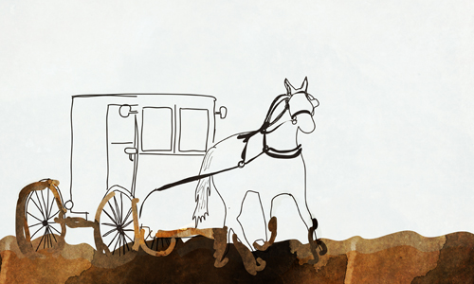
Illustrated by Sefira Ross

Something was terribly wrong with the city of Bar in central Ukraine. Instead of spending days and nights in yeshiva, the youth now trifled their time in the streets, sneering at religion. They embraced every opportunity to ridicule Chassidic rabbis and their simple faith, but Rabbi Zusha of Anipoli, who journeyed from town to town looking for Jewish souls he could help, bore the brunt of their scorn, enduring malice every time he visited the city.
Rabbi Zusha secured his few worldly possessions on the wagon’s bed and climbed into the passenger seat. Before the driver could direct the horses forward, Rabbi Zusha held out a few kopeks.
“I’m aware that the road goes through Bar,” he said, “but I ask you not to enter the town. I know it is quicker to go through the city, so here is payment for the additional distance. Please, whatever you do, don’t enter the city!”
The wagon began to move, and before long the rhythmic swaying lulled Rabbi Zusha to sleep. As the town of Bar appeared on the horizon beneath the darkening sky, a carriage sidled close to the wagon and Rabbi Moshe of Pshevorsk—a renowned scribe and a student of Rabbi Zusha’s brother, Rabbi Elimelech—poked his head out from one of its windows. The wagon driver slowed to a stop.
“Who’s riding with you?” Rabbi Moshe asked, motioning to the sleeping bundle.
“Rabbi Zusha of Anipoli.”
“Are you traveling through Bar?”
“Oh no,” the driver shook his head. “Rabbi Zusha gave me specific instructions not to go there.”
“Well then,” Rabbi Moshe went on, “I advise you to redirect the wagon to Bar. Nothing will happen to you. I promise. But if you decide not to go, it might not end well.”
Rabbi Moshe signaled to his driver and they rode off. The carriage’s rattling slowly faded, leaving the wagon driver quietly weighing his options.
Should he obey Rabbi Zusha or Rabbi Moshe?
He picked up the reins and urged the old horse into action, heading directly towards Bar. Circumventing the town would make the journey much longer, and besides, the wagon driver had Rabbi Moshe’s assurance that nothing would happen to them.
As the horse slowed, Rabbi Zusha awoke, sat up, looked around at the familiar streets, and realized where he was.
“Zusha! You wicked person,” he moaned. “How dare you travel through such an impure city?”
Although the rabbi’s reproach was self-directed, the wagon driver knew Rabbi Zusha had a peculiar way of censuring others. He quickly tried to placate him by offering, “I’m sorry, it was a mistake. If you want, we can retrace our steps and go around.”
But it was too late. The sun had already dipped beyond the horizon and Rabbi Zusha was particular not to travel at night. Seeing no alternative, he requested a room at an out-of-the-way inn, selected specifically so that no one would learn of his presence. But every inn was full and he was left with no choice but to ask his wagon driver to take him to the community hostel, the hekdesh, where all travelers were welcome to rest free of charge. Quietly, he spread his bedding in a corner and turned his face towards the wall.
Word of his presence soon spread and a crowd gathered around the sleeping rabbi. Cheering noisily, they began playing cards, peppering their conversations with inventive profanities. The ruffians glanced over at Rabbi Zusha frequently, waiting to see how he would react to their provocation.
Finally, Rabbi Zusha could take it no more. He sat up and said to himself loudly, “You wicked person, Zusha, oh you wicked person! Remember the time you sinned? Do you recall the despicable acts you did in that place? You did this particular sin. And in the other place, you committed this and this sin…?”
Hardly believing their ears, the young men lowered their cards and watched the old man in the corner. Rabbi Zusha was still going at it, listing sins they themselves had committed as though reading them off a piece of paper.
“And what are you going to claim on Judgement Day, eh, Zusha? Your soul will know no peace when that time comes!”
Rabbi Zusha’s words had their desired effect. The young men dropped their cards and covered their faces, deeply ashamed. Some sobbed while others were stunned into silence.
After some time the erstwhile tormenters approached Rabbi Zusha with a collective request for help. Rabbi Zusha saw their honest expressions and downcast eyes and created a personalized path of repentance for each one.
By morning, word of the night’s wondrous events had spread through the town, and everyone else wanted to ask the saintly visitor to help them too. Many, however, were ashamed to approach him, fearing he would see their sordid secrets.
This was Rabbi Moshe’s cue. He had arrived in Bar to greet Rabbi Zusha and couldn’t help but beam delightedly when he found a sizeable group of desperate young people wanting to repent. Rabbi Moshe explained the situation to Rabbi Zusha, who approached each one individually and helped them amend their wayward behavior.
From that time forward, Rabbi Zusha was never again bothered in Bar. On the contrary, whenever he passed through the city, he was greeted warmly and exuberantly, and kept busy advising and encouraging the now good-hearted townsfolk.

Reprinted from the Parshas Vayeilech 5779 email of Chabad.Org Magazine.

A Blast from the Recent Past (October 1, 2015)

Reb Berke Schiff, 76,
Worked to Help Russian
Jews in the USSR and Israel
By Dovid Margolin

He focused largely on educating children, in particular, those in the Bukharan community

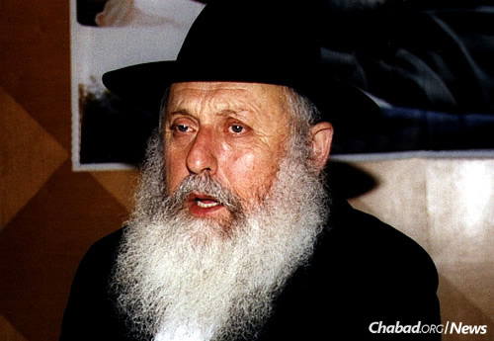

Reb Berke Schiff passed away unexpectedly on Sept. 19 at his home in Lod, Israel the Shabbat between Rosh Hashanah and Yom Kippur. He was 76 years old.
Reb Berke Schiff possessed a trait paramount to the survival of Jewish life in the Soviet underground: He was a man who could be trusted. As a key activist in the secret Chabad-Lubavitch community that flourished in isolation for more than a quarter-century—from 1946 until 1972 in Samarkand, Soviet Asia—Schiff helped fellow Jews find jobs that didn’t require them to work on Shabbat; taught Torah and encouraged mitzvah observance among local Bukharan Jews; and accepted clandestine missions on behalf of the Jewish community that saw him travel thousands of miles into the Russian wilderness.
In the process, he helped found Chamah, an underground Jewish welfare and educational organization directed by his friend and mentor, Rabbi Moshe Nissilevich. Later in Israel, he did the same for the Ohr Simcha-Bukharim Yeshiva for Sephardic Russian-Jewish immigrants from in and around Uzbekistan.
In 1964, he set out on a journey that would echo the fate of Russian Jewry.
Shortly after marrying Batya (Rabinovich) in Samarkand, Schiff was asked by his new in-laws to travel to Kursk, some 2,000 miles away, to ensure the proper circumcision of their newborn twin grandsons—the children of Batya’s brother and sister-in-law, who were no longer religious.

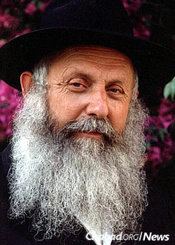
Schiff in his later years.

Before he left, Schiff was informed by Nissilevich of a message relayed by Chief Rabbi Yehuda Leib Levin in Moscow, who had received a letter from a man by the name of Miyasin living thousands of kilometers away in a remote Siberian village. The letter-writer said he had three Torah scrolls in his possession and asked the Jewish community to salvage them before he passed on. Nissilevich asked Schiff to accept the mission.
Arriving in Moscow, Schiff proceeded to Kursk with Reb Mottel Lifschitz (more commonly known as Reb Mottel der Shoichet, a survivor of decades-long Soviet persecution who served for decades as Moscow’s only shochet and mohel), who circumcised the boys in the presence of their mother and Schiff. Once back in Moscow, Schiff wavered about whether to follow up with his assignment to search out an anonymous old man in the middle of nowhere hoping to find Torah scrolls.
“Borke decided to look up plane tickets that went to that region,” recalls Rabbi Betzalel Schiff, Schiff’s younger brother, referring to him by his Russian nickname. “If there was anything available, it would be a sign he should go.”

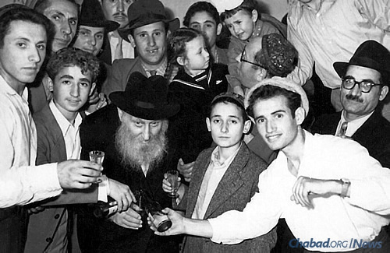
Berke Schiff, left, and above him his father, Yosef Schiff. Fourth from left is Berke's older brother, Aryeh Leib. Reb Yerachmiel Chodosh, Yosef's father-in-law, is in the center.

He got the tickets and boarded a flight to Krasnoyarsk. “He went in his little city shoes; he wasn’t ready for Siberian weather at all,” says his brother, one of the founders of Shamir Publishing House in Jerusalem, which specializes in Jewish books in Russian.
The old man’s letter had said that when the Jewish community’s messenger got close to his village, he should start asking around for Myasin, and someone would direct him. Two flights and a rocky bus ride later, Schiff found himself at the ends of the earth. Hours passed, and Schiff scolded himself for his own poor judgment. “Then one person told him he heard of a Myasin, and his house was up the hill. He told him he had just died.”
The Siberian snow drifts were piled high. Schiff trudged ahead. A Russian peasant took pity on him and gave him a pair of boots before walking him to the correct hut, outside of which a few older Russian women stood, sobbing. “You’re the man from Moscow?” the women exclaimed. “How he waited for you! He said someone who looked like you would be coming around. He passed away early this morning.”

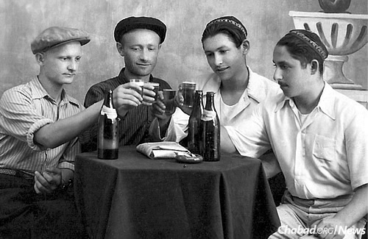
The founding of Chamah: Four young men gather and swore to uphold Judaism with self-sacrifice. From left is Berel Zaltzman, Moshe Nissilevich, Aryeh Leib Schiff and Berke Schiff. On the table sits a Tanya wrapped in a "Pravda" newspaper.

Still unsure if the deceased was even a Jew, Schiff stepped into the house. A body covered by a tallis lay on the table. Candles burned in the room. Along the wall was an ark with an emblazoned Star of David and inside three Torah scrolls, just as the old man had promised in his letter, along with a machzor, siddur and a shofar.
“They were all converts,” explains Betzalel Schiff, noting that the machzor, which his brother kept for many years, was printed using an old Russian translation. “They had been sent into exile for converting to Judaism years earlier. Because of communism, they all stopped being religious except this one man.”
Schiff sat up the entire night saying tehillim (psalms) near the body, as is customary. The next morning, Myasin’s family arranged for a dog sled to take him to the bus station. A few days later, he was home in Samarkand with the scrolls.

The Stringent Soviet Era
Gershon Dovber Schiff was born in 1938 in Voronezh, Russia, the second of Yosef and Malka Schiff’s four children. His grandfather had studied at the famed Lithuanian yeshivahof Volozhin before settling in Voronezh and becoming a wealthy man. In the early 1920s, the Sixth Lubavitcher Rebbe—Rabbi Yosef Yitzchak Schneersohn, of righteous memory—arrived in Voronezh. The Rebbe’s grandson was ill with typhus, and so the only one who agreed to host the party was the elder Schiff.

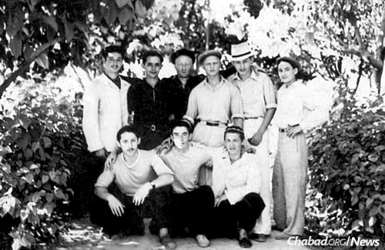
A meeting of young Chamah activists in Samarkand. Schiff can be see in the bottom row, far left.

In return for the kindness, Rabbi Yosef Yitzchak offered to take Schiff’s son, Yosef, back with him to study at the yeshivah then located in Rostov.
“That’s when my father became a Lubavitcher, as did the entire family,” relates Betzalel Schiff. “Then he married my mother, who was the daughter of Reb Yerachmiel Chodosh and came from an old Lubavitcher family.”
Berke came into communal work in the late 1950s during an extraordinarily difficult period for Jews in the Soviet Union. Years earlier, with news of Nazi atrocities reaching Jews in Russia and German troops rapidly approaching, thousands of Jews fled their homes in Ukraine and Russia, and headed east with a large Chabad refugee community to Samarkand and Tashkent. Among them was Malka Schiff and her three children at the time—Berke the middle one—while her husband Yosef was at the front. Schiff’s father returned from the war in 1943, minus the use of an arm.
When the war ended and a window of opportunity to leave the USSR via Polish repatriation presented itself, a majority of the Chabad community-in-exile escaped on westward-bound trains using falsified Polish papers. The operation was expensive and dangerous; a number of organizers were arrested and imprisoned, where they either died or spent long, hard years. And then there were the families who hadn’t managed to procure the proper papers in time. Locked behind a newly reinforced “Iron Curtain,” the community of 40 or 50 families stayed in Samarkand, a place far from the center of Soviet power in Moscow where they could more easily hide the existence of a religious community.

Life in Samarkand
The Chassidic community in Samarkand had all the staples of Jewish life: a cheder(literally a “room,” a traditional elementary school) for younger children, a yeshivah, places where a Shabbat minyan could be held and a mikvah. Although far safer than in the larger eastern Russian cities, the Jewish infrastructure had to be kept hidden as long as it was functioning.
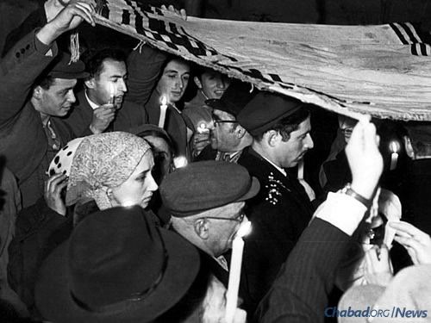
Berke and Batya (Rabinovich) Schiff's chuppah in Samarkand.

Schiff’s father was an injured veteran, and after the war had been forced to join the Communist Party. That meant his legal status was more clearly defined than many of those who had not served in the military, let alone been injured. As a party member, he was able to manage a factory where he worked to employ Jews and use his status to pull strings for the community.
Berke followed his father’s lead, and after the elder Schiff fell ill took over the factory. As a boss, or nachalnik—a coveted status in the former Soviet Union to this day—the younger Schiff became relatively wealthy himself, purchasing a home in Samarkand that for a while served as a synagogue and yeshivah for the community. (A yeshivah could not stay in one place indefinitely because it was only time before a neighbor became suspicious of the activity.)
“My father wasn’t afraid to do anything,” says Berke’s daughter Chana Mishulovin. “He didn’t hesitate; if something had to be done, he did it.”
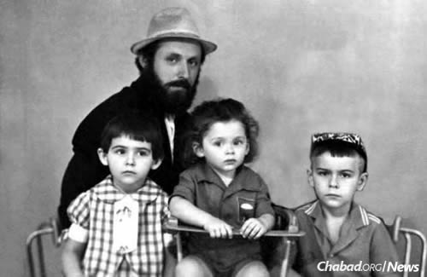
Berke Schiff poses with three of his children just prior to his emigration from the Soviet Union.

When the famed Reb Mendel Futerfas, who had helped organize the Lubavitchcommunity’s escape to the West in 1946-48 before being caught and sent to a gulag for 14 years, was finally freed and arrived to join the community in Samarkand, it was Berke Schiff who greeted him.
“The great tzaddik Mendel Futerfas, he came to Samarkand and everyone was afraid to visit him” because he was a convict, shares Betzalel Schiff. “But someone needed to bring him food. Borke wasn’t afraid; he went to him, and brought him eggs and milk. And when Reb Mendel got permission to leave, who saw him off? Borke Schiff!”
Surrounding the Chassidic community were thousands of Bukharan Jews. Traditional, pious people, they had lived in Asia for generations and kept their religious flame alive. Chabad had had a long connection with the Bukharan Jews, stretching back to the 1890s when the first Lubavitcher arrived there and began working to raise the level of Jewish education. When Chamah was founded, one of its goals was to teach Torah to the Bukharan children, with young activists such as Schiff, Rabbis Hillel and Berel Zaltzman, and Rabbi Moshiach Chudaitov traveling throughout the countryside setting up chedersand yeshivahs in order to do so.
That’s when Schiff learned their language and customs, which would later prove invaluable in Israel.

Festival of Freedom
By 1972, much of the remaining Chabad community was finally given permission to leave the Soviet Union. Many settled in Israel, among them the extended Schiff family. That Passover, the Lubavitcher Rebbe—Rabbi Menachem M. Schneerson, of righteous memory—paid for the new immigrants to come to New York and celebrate the holiday at Lubavitch World Headquarters at 770 Eastern Parkway in the Crown Heights neighborhood of Brooklyn, N.Y.

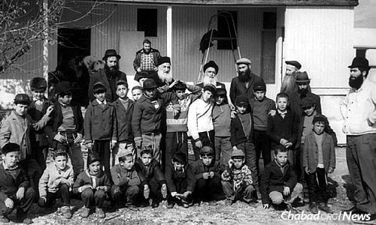
The early beginnings of Yeshivat HaBukharim in Kfar Chabad, Israel. From left are Berke Schiff, Rabbi Avraham Chaim Ledaiov, Rabbi Zevulun Leviev, Rabbi Hillel Zaltzman, Rabbi Moshe Nissilevitch, Rabbi Lipa Klein and Rabbi Yehoshua Raskin.

After speaking about the “Mah Nishtanah?”—the four questions traditionally asked by children at the Passover seder—at the farbrengen on the first day of Passover, the Rebbe addressed the crowd.
“Is there a child here who has recently left Egypt?” he asked.
There was. Berke’s son Yerachmiel and Yerachmiel’s cousin were lifted over the crowd and deposited near the Rebbe, who poured them some wine and wished them a l’chaim. Then, in a flawless Yiddish, the Russian boys proceeded to ask “The Four Questions,” ending with the traditional “Tatte, I have asked of you the questions, now, please give me an answer.”
“The Rebbe was very emotional,” remembers Schiff. “And he started singing ‘Ee v’vade mi ne utonim, ee v’agne mi ne zgarim,’ and the whole room was singing.”
The Russian words were the ultimate anthem of the hardscrabble Russian Chassidim, sung over and over, faster and faster: “And in water we will not drown, and in fire we will not burn.”

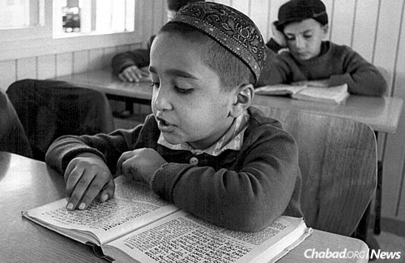
A Bukharan child studies at Schiff's yeshivah. Schiff connected with the students and the families, including linguistically, building a massive institution in the process.

Building a School and a Home
When Schiff had been at his private audience with the Rebbe, he had noted that many recent Bukharan immigrants to Israel had been integrating poorly into society. The Rebbe suggested that Schiff take the situation into his own hands.
Over the next year, Schiff worked to place the children in religious Jewish schools throughout Israel. Families in the Chassidic village of Kfar Chabad took many in and transformed a school that was closing in nearby Rishon Letzion into a dormitory. Still, it was an uphill battle; despite finding the youngsters housing closer to Jewish schools, many of the schools turned down the children. Delinquency rates within the Bukharan Jewish community skyrocketed.
During his next private audience in 1974, the Rebbe made it clear that he meant Berke should start his own institution to care for the children.

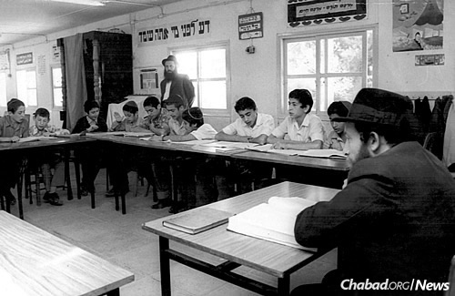
A class at Ohr Simcha-Yeshivat HaBukharim. Schiff stands against the window.

Arriving back in Israel, Schiff founded Yeshivat HaBukharim in Kfar Chabad together with Rabbi Simcha Gorodetsky—after whom it was named Ohr Simcha when he passed away in the early 1990s—and the help of Reb Shlomo Maidanchik and others, running the rapidly growing institution out of a collection of trailers. More than just a providing an education (many of the children were illiterate coming from Bukhara), the yeshivah took youngsters from broken homes and provided them with a stable atmosphere geared uniquely towards them.
“Even if the other schools would have accepted these children, they didn’t know how to handle them,” says Schiff. “They were coming from a different world. The parents knew and respected Borke from Samarkand; he spoke their language and knew their ways, and he understood them in a way others simply couldn’t.”
Chana Mishulovin remembers her father being totally dedicated to the cause.
“He was out of the house at 6 a.m. and driving to pick up the ‘house mothers,’ ” she says. “It wasn’t like a regular school. There were kids who were 6 years old there, and there needed to be food and clothing and everything to make it like home. Food was very important to my father. He never wanted the institution to skimp; he wanted the children to have big, healthy meals.”
No matter what was happening, Schiff made sure to keep the Rebbe appraised of the successes and challenges of the Bukharan Jews.
“He was like a soldier, he kept moving,” says his daughter. “He never wrote a journal; he was just busy, busy, busy. He saved thousands of young men from the street.”
The yeshivah grew to encompass a vast campus, including school buildings and dormitories, and continues to operate today.
Schiff’s brother remembers sitting together with Reb Mendel Futerfas at one of Berke’s family occasions. “He kept saying Borke, Borke, Borke, and he told us, ‘You know why I call him Borke? Because after 120, he’s going to go up to heaven, and they’re going to pull out their list of names to judge him.
They’ll ask him his name, and he’ll answer Gershon Ber. They’ll look at the paper and won’t find that name. He’ll tell them he’s also known as Borke from Samarkand.
“They’ll look again and tell him, ‘Borke from Samarkand? We have a long list of good deeds for you. We know exactly who you are.’ ”
In addition to his wife, Schiff is survived by his children: Yerachmiel Schiff, Chana Mishulovin, Yoske Schiff, Michoel Schiff, Malky Chabib, Schneur Schiff and Mendy Schiff; and many grandchildren and great-grandchildren. He is also survived by siblings Aryeh Leib Schiff, Devorah Chein and Betzalel Schiff.

Reprinted from the October 1, 2015 website of Chabad.Org

